**Jenkins Notes**

Continuous integration tool for automation, daily routine things, building jar, running automation test case etc.

Real time scenario – 500 test cases , we can trigger on a single shot by testing or maven plugin even that is a manual wok as we need to click a button.

We need all automation – if we schedule script to run at 2 am and the script is 6 hour long, we will create a job in Jenkins and will give the command to the run the script.

Jenkins knows how to run the commands

Smoke job – automatically gets executed once the developer pushes the new code. If the environment is changed

Also, the business user will see the reports generated by the Jenkins.

The ’Build Now ‘link is used to run the scheduled jobs

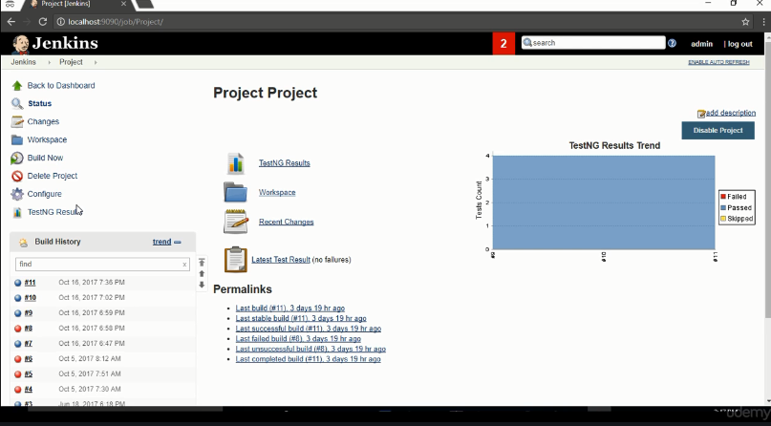

Also, the to maintain consistency across the reports and avoid the dependency, the Jenkins have its own environment that helps in consistency

Ex- test ng version 6 is used to develop the tests whereas for the other guy, he is using the latest version of the test ng and the hence there can be difference in the output, so Jenkins is used

If there is some problem with the TEST Ng version 6, we can select the TEST Ng 5 to get the results to get the consistency

Real time problem – if the people say that the scripts are failing in their system but they are passing in Jenkins because the system is having the latest jars for Test Ng which is making the results inconsistent

Also if there are multiple teams across different geographical locations, then Jenkins helps to make it centralized and common configuration

**Installation and configuration**

Jenkins run on the company server and every company has it which is provided by the devops engineer

Download the Jenkins. War

And in the command line enter java -jar Jenkins.war –httpPort =8080 – to execute this war file

All we need for configuration is maven and java

Jenkins has all the tools and plugins to run all the maven commands. The maven is integrated with jenkins